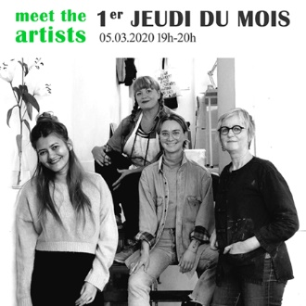

1st Thursday of the Month
“Open Studio”
March 5th, 2020 from 7pm to 8pm.
=> Atelier A.I.R. Vallauris, 21 avenue de Cannes, Vallauris, France. 06220
It is with great pleasure that we invite you to meet our 4 resident artists and discover their works in progress:
Danielle Becknell (Australia/USA), Carrie Kennedy (Australia), Roxanne Macmod (Philippines/UAE) and Marleen Vansteenvoort (Belgium)
.
=> Galerie Aqui Siam Ben Place Lisnard, 1 boulevard des Deux Vallons, Vallauris, France. 06220
We will also welcome you at the Gallery Aqui Siam Ben during this event.

FR
1er Jeudi du mois
« Visite d'atelier»
jeudi 5 mars 2020 de 19h à 20h.
=> Atelier A.I.R. Vallauris
21 avenue de Cannes, Vallauris, France. 06220
C’est avec plaisir que nous vous invitons à venir à la rencontre de nos 4 artistes en résidence et de découvrir leurs œuvres en cours de réalisation:
Danielle Becknell ( Australie/USA), Carrie Kennedy (Australie), Roxanne Macmod (Philippines/UAE) and Marleen Vansteenvoort (Belgique)
.
=> Galerie Aqui Siam Ben
Place Lisnard, 1 boulevard des Deux Vallons, Vallauris, France. 06220
Nous vous accueillerons également à la Galerie Aqui Siam Ben lors de cet événement.

